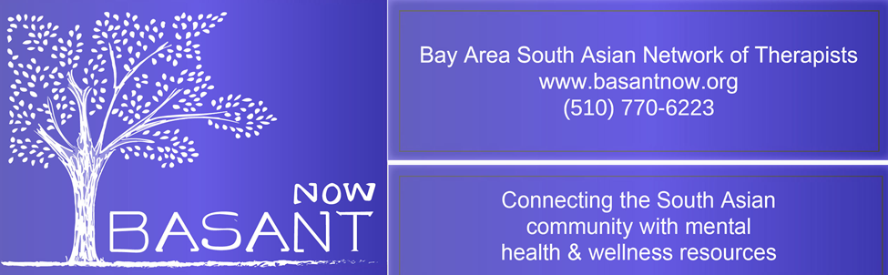
Presents a parenting seminar

You Are Always Yelling At Me

Effectively Communicating With Your Pre-Teens & Teens

Presented by: Shalini Dayal, MFT43574

Saturday, March 31st., 2018 10.30am to 12.30pm
Fremont Main Library, Fukaya Room
- Teen Developmental Stage
- Understanding the Teen Brain
- Risks, Rewards & Defiance
- Challenges Teens Face
- How & When to ‘Talk’ to Your Teen
- Statements to Avoid
- Diffuse Conflicts
- Reflecting & Mirroring
- Connecting with Teens
Fremont Main Library
2400 Stevenson Blvd., Fremont, Ca 94538
510-745-1421 Voice TTY 888-663-0660
The Library is wheelchair accessible.
www.aclibrary.org 2/2015

